**Validations:**

**We have 2 Types of Validation irrespective of Technology. Client Side & Server Side Validations.**

* **Client Side:- The Validation which gets executed on Refresh of Screen.**
* **Server Side:- The Validation which gets executed on Submit of UI or On Processing of Business Logic.**

**Validation Purpose: Expected values are not provided it will throw error message.**

**Validation Types:**

1. **Constraints**
2. **Rule -Obj-Validate ( Validate Rule)/ Process Validate Rule/Page Validations**
3. **Rule-Edit -Validate ( Edit Validate Rule)/Advanced Validations**

**Working with Validate /Rule-Obj-Validate:**

**Process-> Validate**

**Validate Rule:**

* **Validate rule is created under Process category**
* **We can use predefined functions to perform validation.**
* **After Adding Validation, we have to call under Validate Rule, Flowaction ( Validation Tab) & Activity ( Obj-Validate)**
* **When adding Validation we have to use properties from one design only, because these are page validations.**

**====================**

**Req: Perform Validation on Customer Details screen for below properties:**

* **Validate LName & FName**
* **Validate Age: Age should be b/w 20 & 70**
* **Pincode length should be 6 digits**

**=========**

**Add Validate Rule:     Process -> Validate**

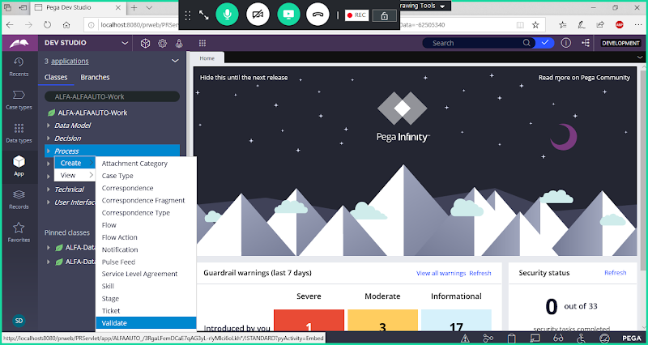

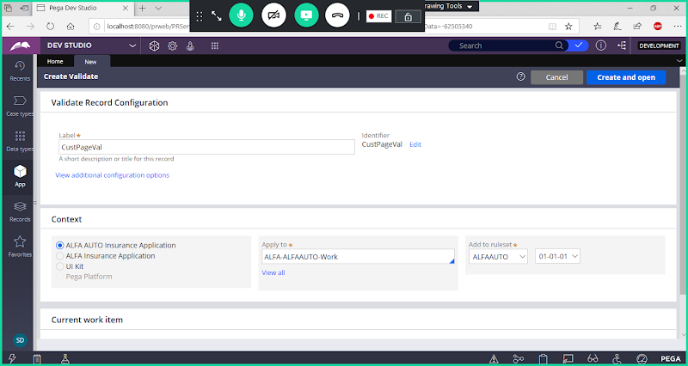

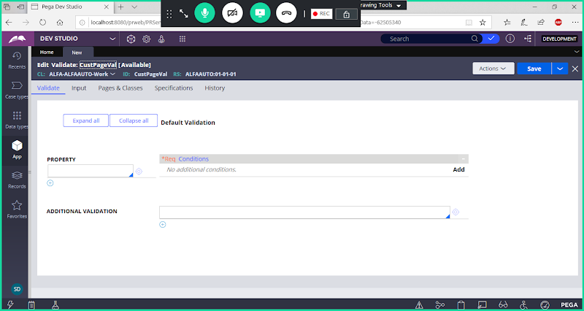

**In validate Rule we can use multiple properties from same section/design**

**Add Validation for FName:**

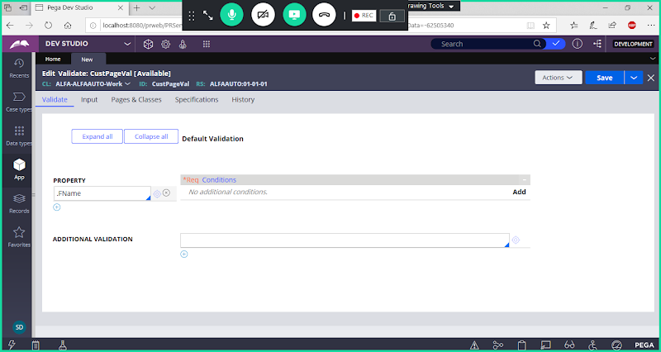

**Click on Add**

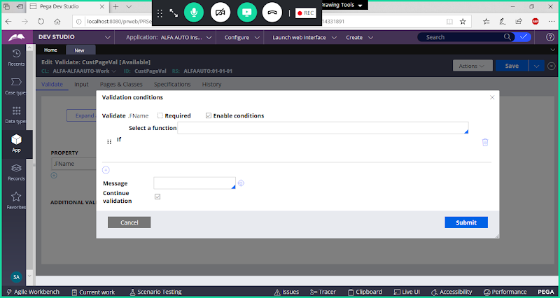

**Select Function: First String Relation Second String**

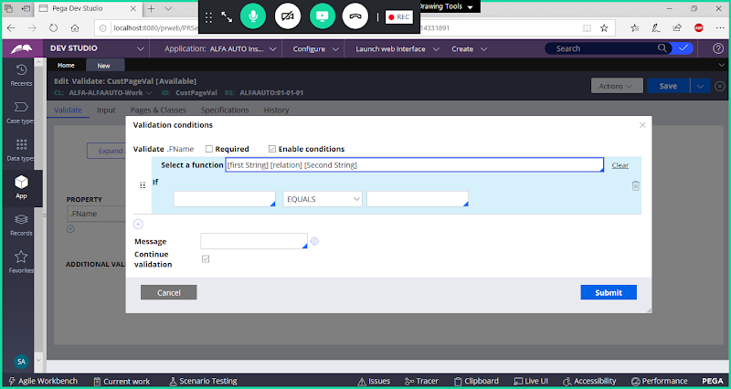

**Fill Parameters**

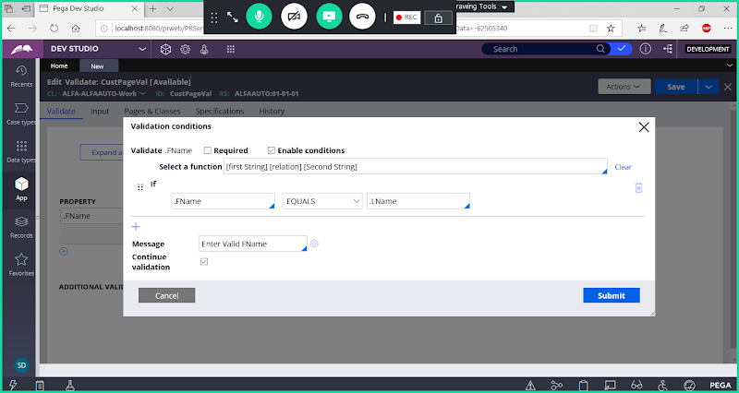

**Submit**

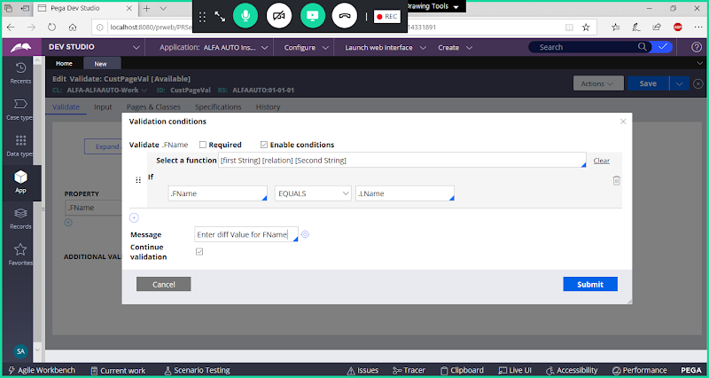

**Click on Submit**

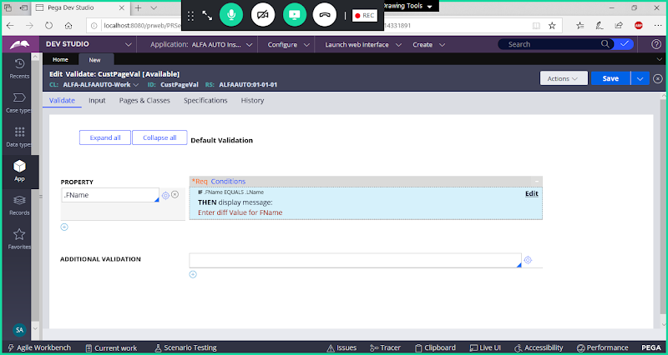

**Add Validation for Age:**

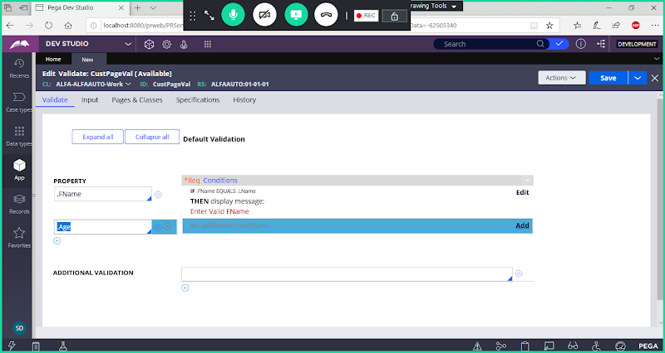

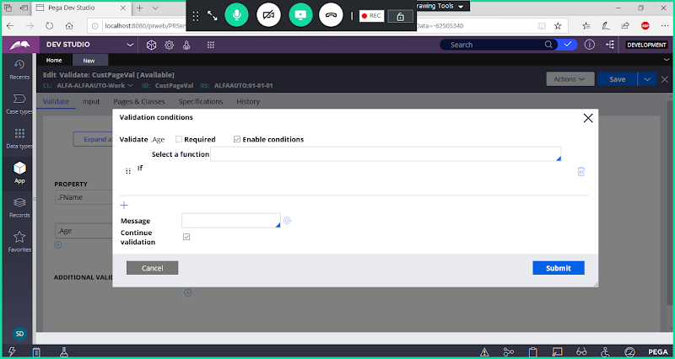

**Select Function**

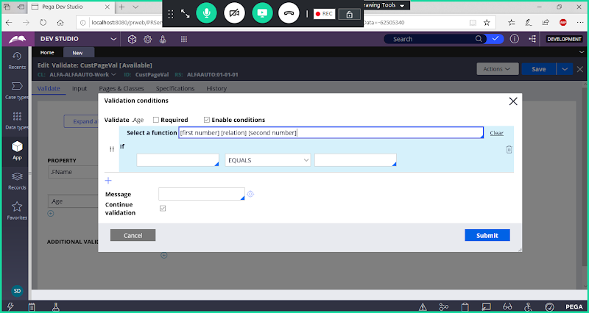

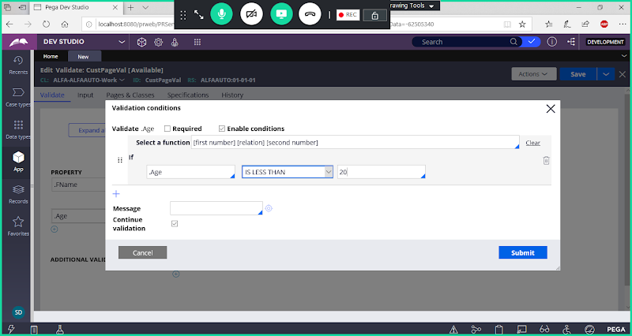

**Click on Add Row & Select Function:**

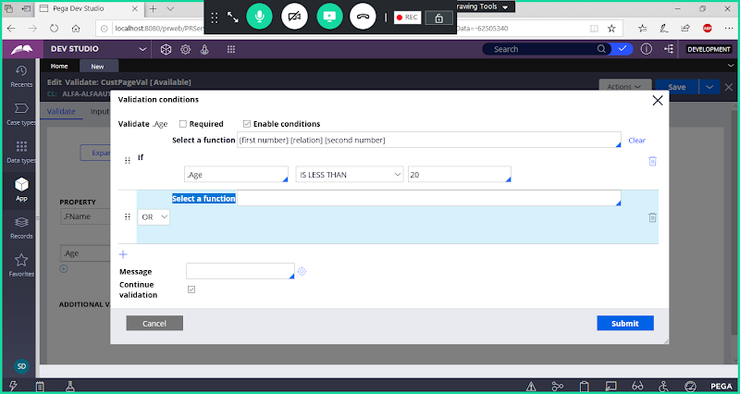

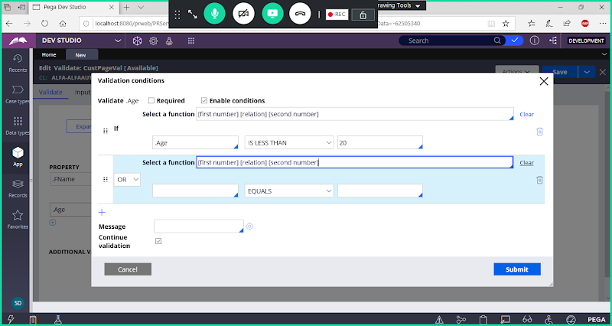

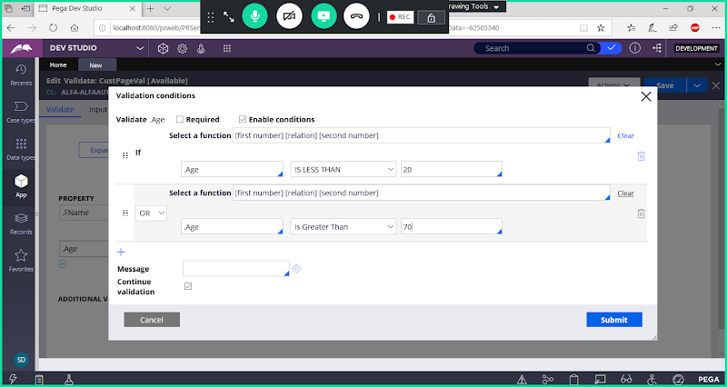

**Now Add Message**

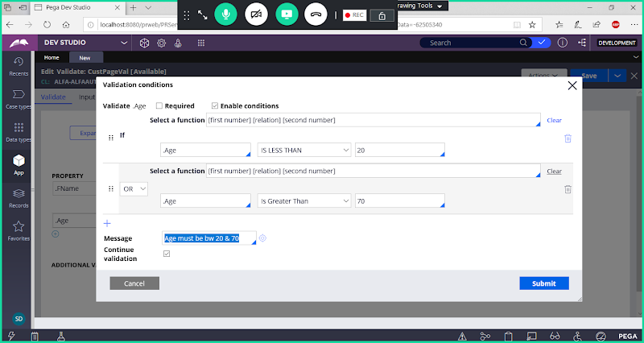

**Submit**

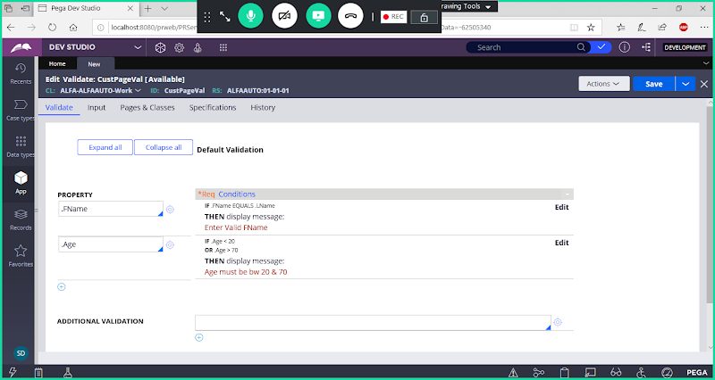

**Add Validation for Pincode:**

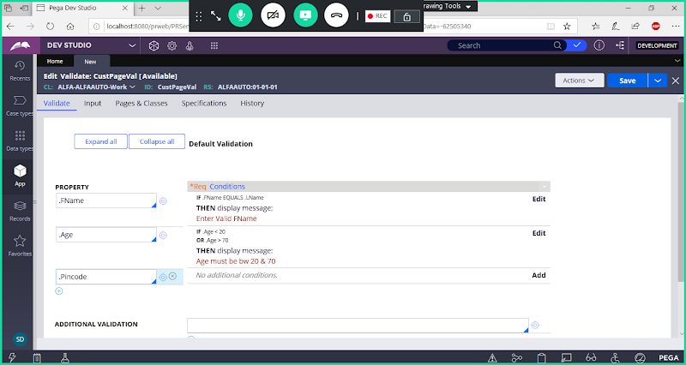

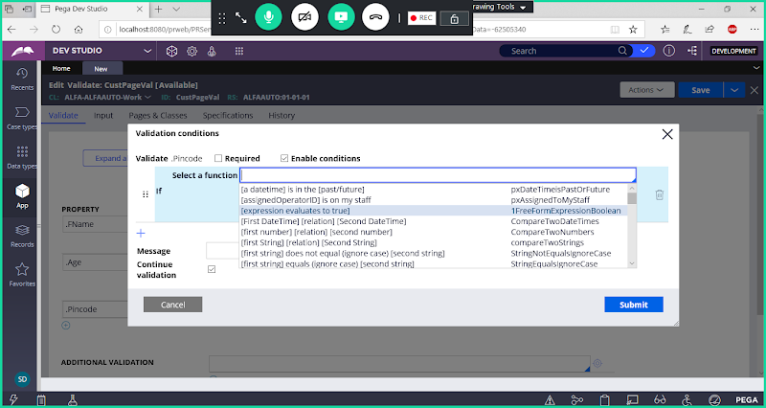

**Click on Add-> Select Function Expression evaluates to True ( This will open expression Builder)**

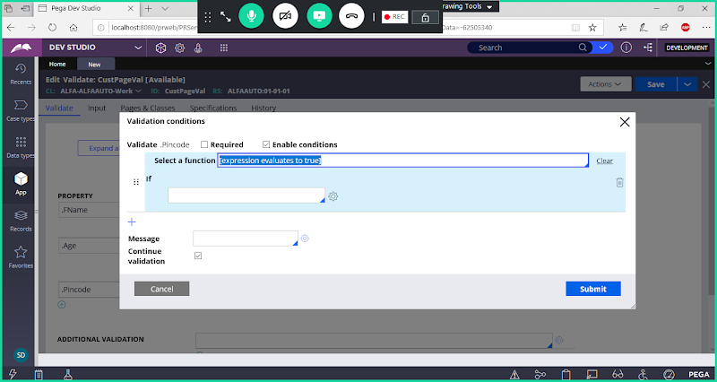

**Open Expression Builder**

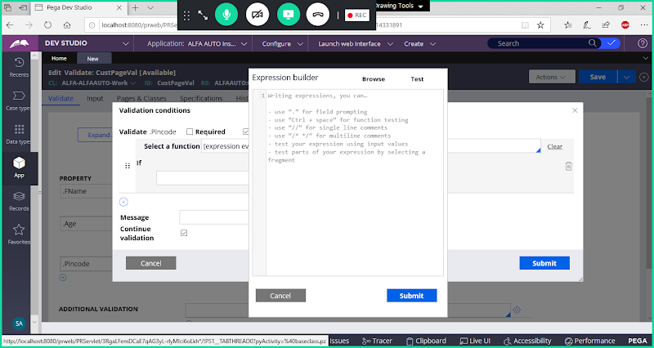

**Click on Browse & Add Length Function:**

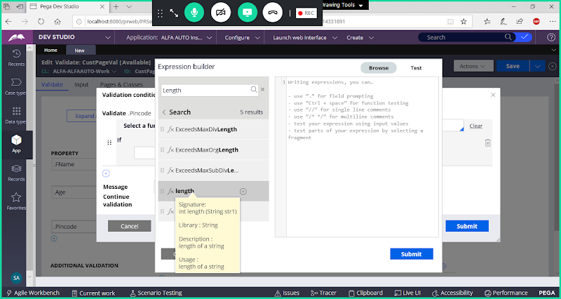

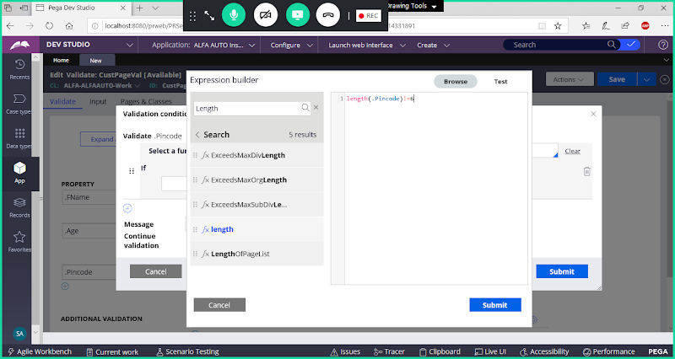

**Submit**

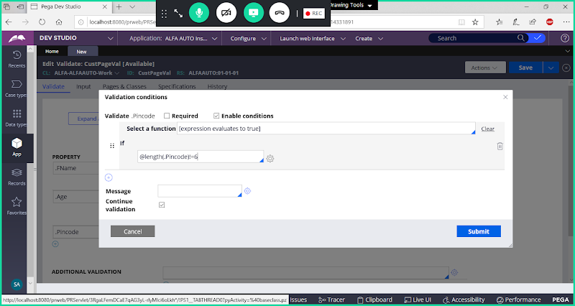

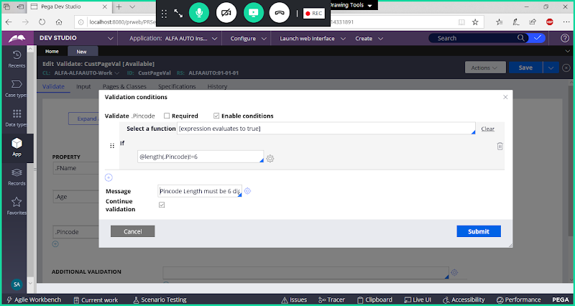

**Submit**

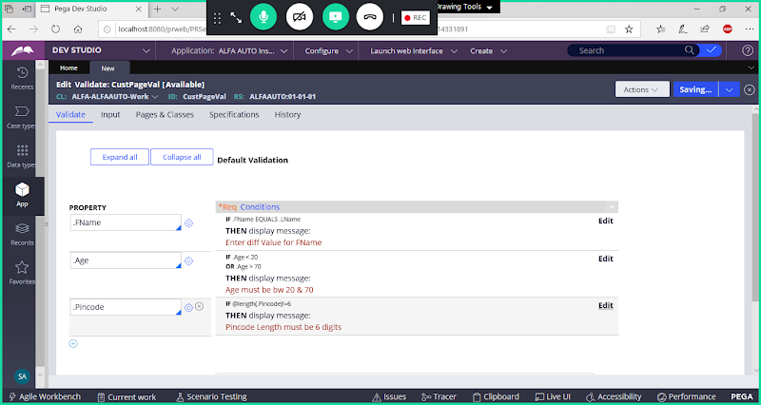

**Save Validate Rule**

**Call Validate rule in Customer Details Flowaction.( In Flowaction go to Validation tab)**

**Open Customer Details Flowaction**

**Go to  Validation Tab:**

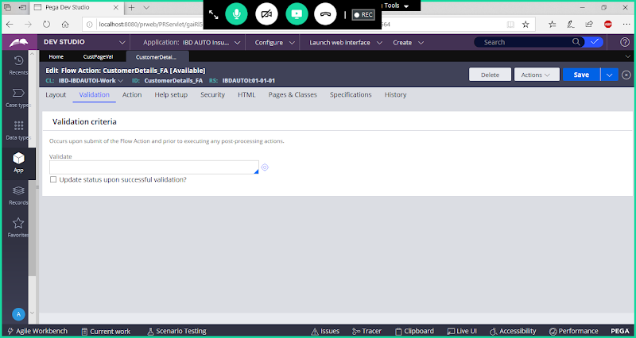

**Call Validation from dropdown**

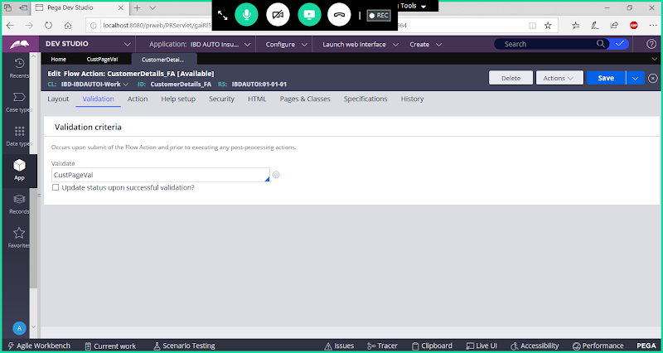

**Save Flowaction & Check in**

**Run Customer Flow**

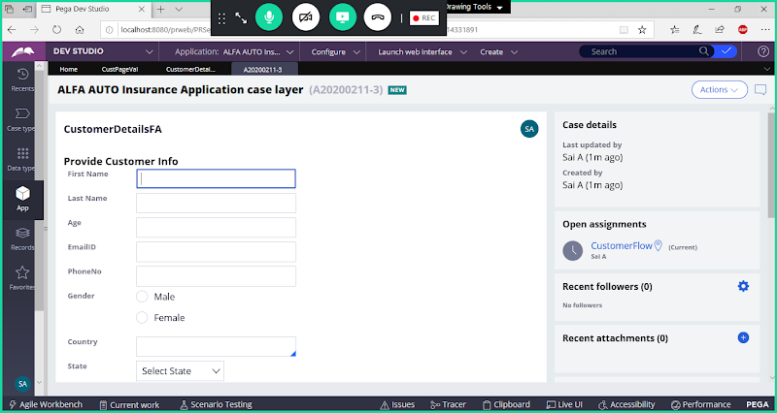

**Enter Values & Submit**

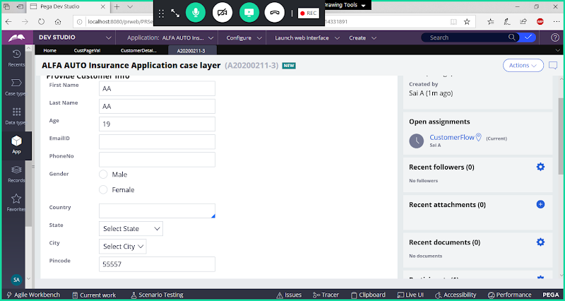

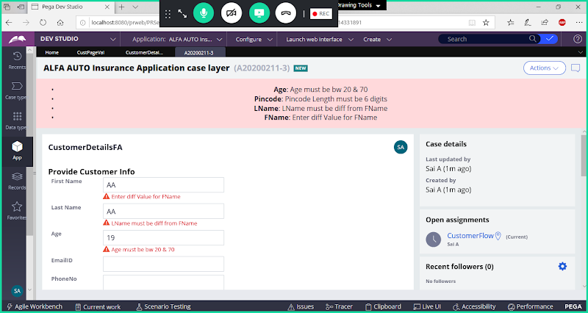

**Give Correct Values then we can submit the WO.**

**How to Call Validate rule in Activity?**

**A: Method: Obj-Validate ( Activity rule we have to call in Flowaction - Action tab we can call activity)**

**=====**